

Loops

Chapter 5 homework



October 14, 2019

Thomas J. short

Cis 260-01

**Chapter 4 Exercises**

5.2.2 How many times are the following loop bodies repeated? What is the output of each loop?

1. Int i = 1; (a) **This loop body will loop an infinite amount of times.**

While (I < 10) **i will always be 1 and 1 % 2 will never be true.**

If (I % 2 == 0) **There will be no output.**

System.out.println(i)

1. Int i = 1; (b) **This loop body will also loop for infinity.**

While (i < 10) **Same thing here as a still no output.**

If ( i % 2 == 0)

System.out.println (i++)

1. Int I = 1; **(c) This body will loop 9 times during this loop it will print 3, 5,7**

While (I < 10)  **and 9**

If ((i++ )% 2 == 0)

System.out.println(i);

5.2.3 What is the output of the following code? Explain the reason.

Int x = 80000000;

While (x>0)

X++;

System.out.println(“x is ” + x);

**X is -214748648**

**Right away I noticed that 80000000 is probably to large of a number for and integer and so when I ran it Integer overflow happened because the range of an integer is -2147483648 to 2147483647.**

5.5.1 Suppose the input is 2, 3, 4, 5, 0. What is the output of the following code?

import java.util.Scanner;

public class Test {

public static void main(String[] args) {

Scanner input = new Scanner(System.in);

int number, max;

number = input.nextInt();

max = number;

while(number != 0) {

number = input.nextInt();

if (number > max)

max = number;

}

System.out.println("max is " + max);

System.out.println("number " + number);

}

}

**Max is 5**

**Number 0**

5.6.1 **This is the same question as 5.5.1 and it will produce the same result as well.**

**max is 5**

**number 0**

**The only difference is we used a do while loop instead of a while loop, which means, that we check the continuation-condition-statement after we execute the loop body at least one time. The do-while loop is written as follows:**

Import java.util.Scanner;

Public class doWhile

{

Public static void main(String[] args)

{

Scanner input = new Scanner(System.in);

Int number, max;

Number = input.nextInt();

If (number > max)

max = number;

}while (number != 0);

System.out.println(“max is ” + max);

System.out.println(“number ” + number);

}

5.6.2 What are the differences between a while loop and a do-while loop? Convert the following while loop into a do-while loop.

Scanner input = new Scanner(System.in);

Int sum = 0;

System.out.println(“Enter an integer “ + “(the input ends if it is 0)”);

Number = input.nextInt();

While (number != 0)

{

Sum += number;

System.out.println(“Enter an integer ” + “(the input ends if it is o)”);

Number = input.nextInt();

}

**The while-loop will always evaluate the continuation-condition-statement before the loop body is executed, if the continuation-condition-statement evaluates to false the loop body is never executed. In a do-while loop we execute the body before we ever check the continuation-condition-statement. The loop body in a do while loop will always be executed once before we ever check the continuation-condition-statement.**

**Scanner input = new Scanner(System.in);**

**Int sum = 0 ;**

**Do**

**{**

**System.out.println(“Enter an integer ” + “(the input ends if it is 0)”);**

**Number = input.nextInt;**

**Sum += number;**

**} while (number != 0);**

5.7.1

Do the following two loops result in the same value in sum?

(a)

for (int i= 0; i < 10; ++i ) {

sum += i;

}

(b)

for (int i = 0; i < 10; i++) {

sum += i;

}

**The same, because we are not using it before or after.**

5.7.3 Suppose the input is 2 3 4 5 0. What is the output of the following code?

Import java.util.Scanner;

Public class test

{

public static void main(String[] args)

{

Scanner input = new Scanner(System.in);

int number, sum = 0; count;

for (count = 0; count < 5; count++)

{

number = input.nextInt();

Sum += number;

}

System.out.println(“sum is ” + sum);

System.out.println(“count is ” + count);

}

}

**sum is 14**

**count is 5**

5.7.6 Convert the following for loop statement to a while loop and to a do-while loop:

long sum = 0;

for (int i = 0; i <= 1000; i++)

sum = sum + i;

**while-loop:**

**int I = 0;**

**long sum = 0;**

**while(I <= 1000)**

**{**

**Sum += i++;**

**}**

5.9.1 How many times is the println statement executed;

For(int i = 0; i < 10; i++)

For(int j = 0; j < i; j++)

System.out.println(i * j)

**The println statement will execute 45 times**

5.9.2 Show the output of the following programs. (Hint: Draw a table and list the variables in the columns to trace these programs.)

(a)

public class Test {

public static void main(String[] args) {

for (int i = 1; i < 5; i++) {

int j = 0;

while (j < i) {

System.out.print(j + " ");

j++;

}

}

}

}

1. **0 0 1 0 1 2 0 1 2 3**

(b)

public class Test {

public static void main(String[] args) {

int i = 0;

while (i < 5) {

for (int j = i; j > 1; j--)

System.out.print(j + " ");

System.out.println("****");

i++;

}

}

}

1. **\*\*\*\***

**\*\*\*\***

**2 \*\*\*\***

**3 2 \*\*\*\***

**4 3 2 \*\*\*\***

(c)

public class Test {

public static void main(String[] args) {

int i = 5;

while (i >= 1) {

int num = 1;

for (int j = 1; j <= i; j++) {

System.out.print(num + "xxx");

num *= 2;

}

System.out.println();

i--;

}

}

}

1. **1xxx2xxx4xxx8xxx16xxx**

**1xxx2xxx4xxx8xxx**

**1xxx2xxx4xxx**

**1xxx2xxx**

**1xxx**

(d)

public class Test {

public static void main(String[] args) {

int i = 1;

do {

int num = 1;

for (int j = 1; j <= i; j++) {

System.out.print(num + "G");

num += 2;

}

System.out.println();

i++;

} while (i <= 5);

}

}

1. **1G**

**1G3G**

**1G3G5G**

**1G3G5G7G**

**1G3G5G7G9G**

**Programming Exercise #5.17**

**Display Pyramid Results:**

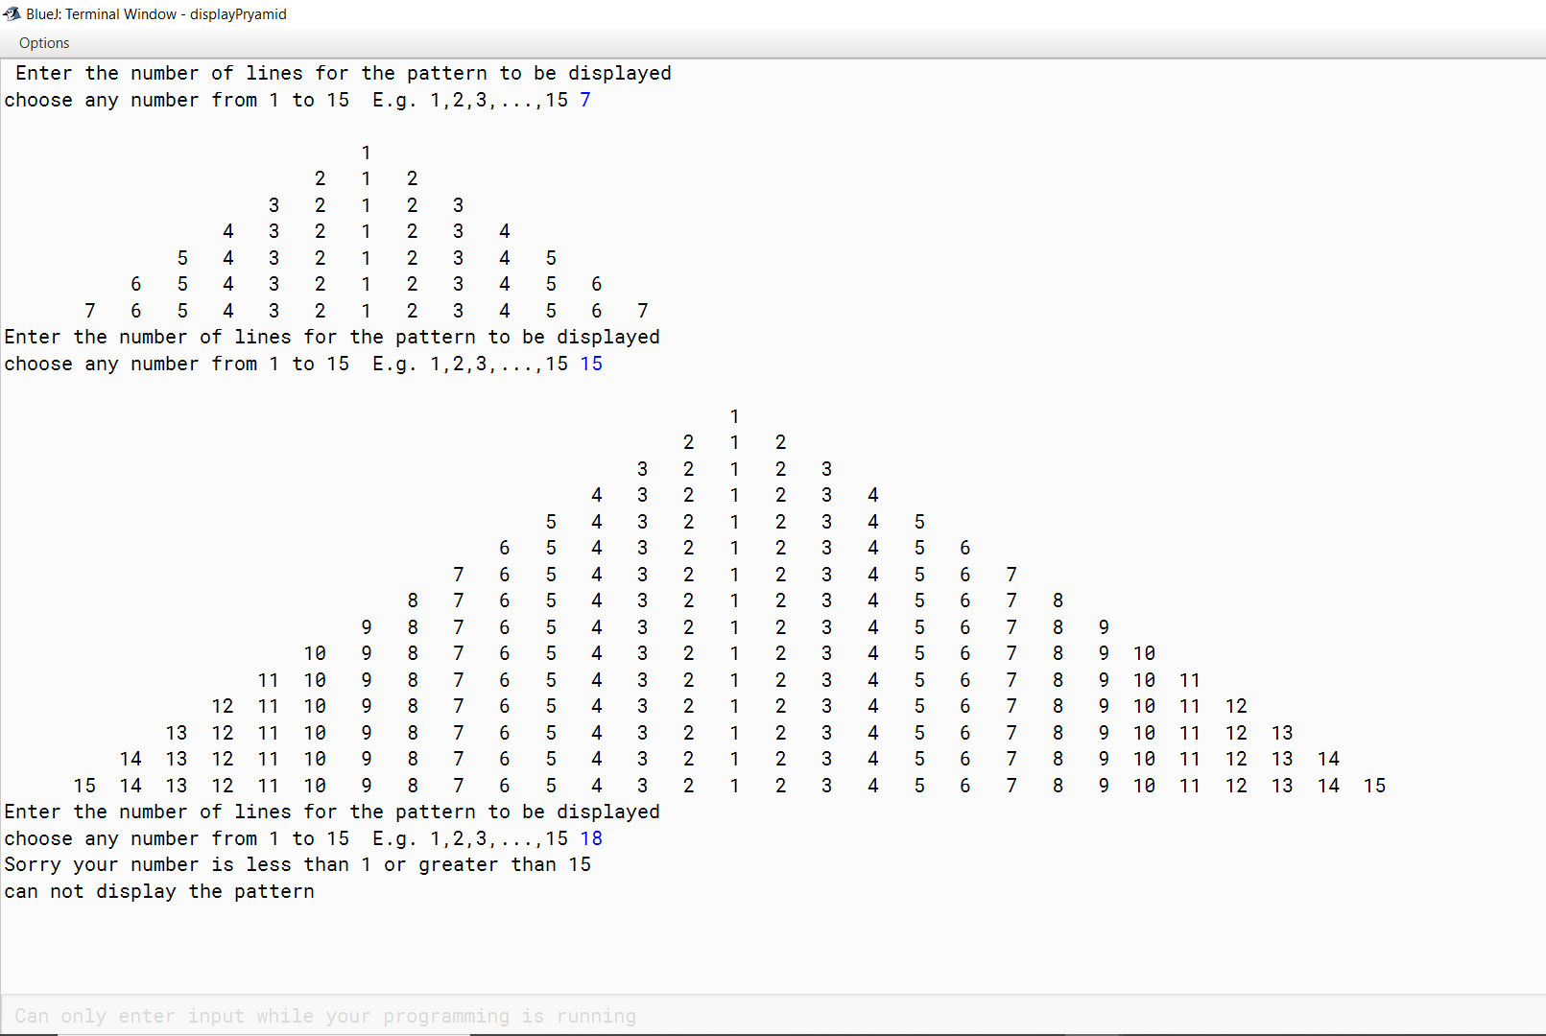

**Programming Exercises #5.49**

**Count Vowels and Consonants**

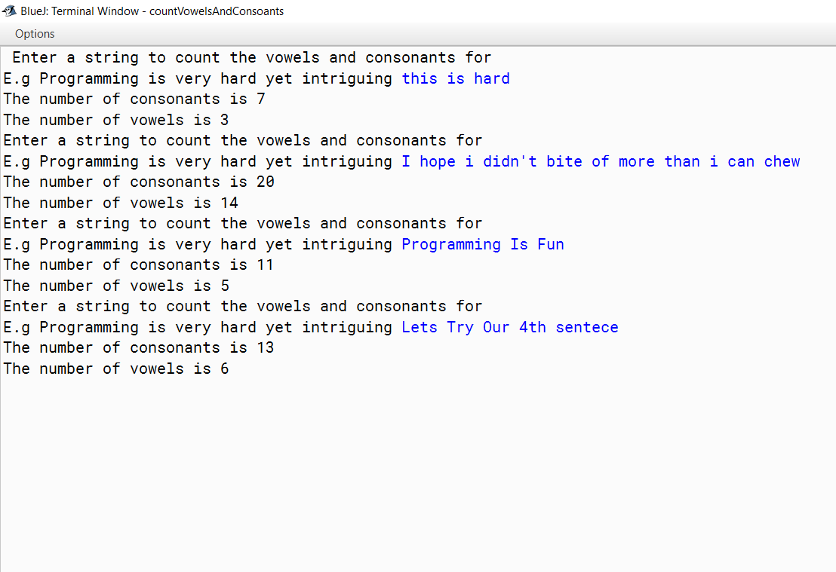

**Miles to kilometer Results**

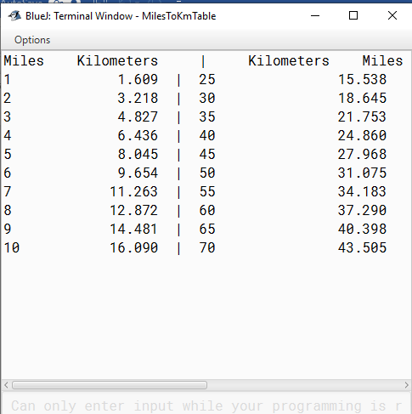

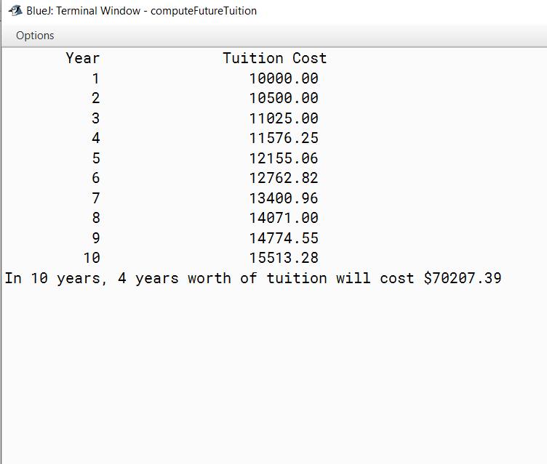**Future tui**

**Cd investment Results:**

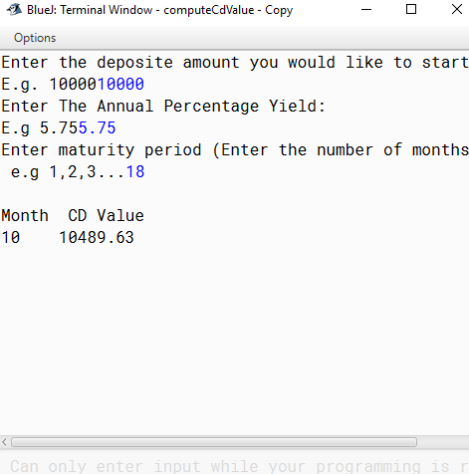

**tion Results**